City of Deer Park
7777 Blue Ash Rd
Deer Park OH, 45236
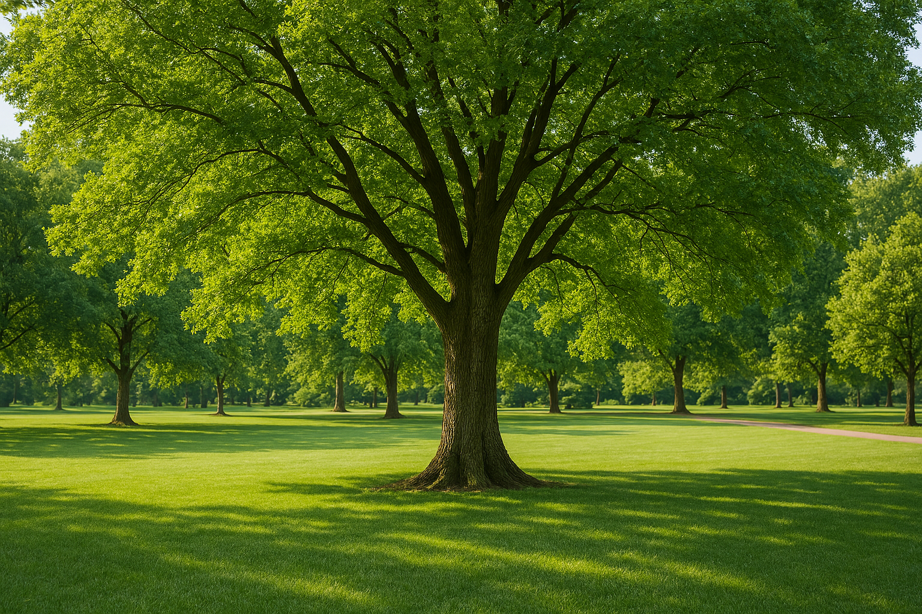

DEDICATION MEMORIAL BRICK
Brick Order Form: 8”x8” Brick Brick Cost: $40.00 plus
S&H: $33.22 (Per Brick)
Dedication Memorial bricks and trees are a great way to memorialize a loved one for generations to come. *Note* At this time a tree must be purchased along with the brick. Tree prices vary, please contact the city office for prices and availability. Please make checks payable to “The City of Deer Park”.

The bricks may contain up to 14 characters and spaces on each of the three lines. To order, fill out the Order Form below and submit with your check to address shown above.

Your Name: ____________________________________________ Phone: _________________

Address: ____________________________________________________________________
Inscription:

For Office Use Only:

Date Received: _____________ Cash/Check/CC: _______________ Date Ordered: ___________

Memorial Tree Order Form

Tree prices vary depending on the species of the tree you wish to have planted. Please check with our Service Department regarding prices and tree species choices.

Name: ___________________________________________ Date: __________________

Address: ____________________________________________________________________

Phone: _________________________________________

________________________________________________________________________________

For Office Use Only:

Price: ______________

Date Received: ______________

Cash/Check/CC: _____________

Date Ordered: _______________

Received By: ________________

